Shell Tutorial

**Part -2 (Accessing File’s content)**

**Overview:**

In this tutorial, our main focus will be on “How to filter file’s content as per our requirement”.

Here we go,

Before moving to the commands, first let’s have a look at the data files.

Here we are having two data files “data.csv” and “data1.csv”.

Note - In computing, a comma-separated values (CSV) file is a delimited text file that uses a comma to separate values.

**Data.csv**

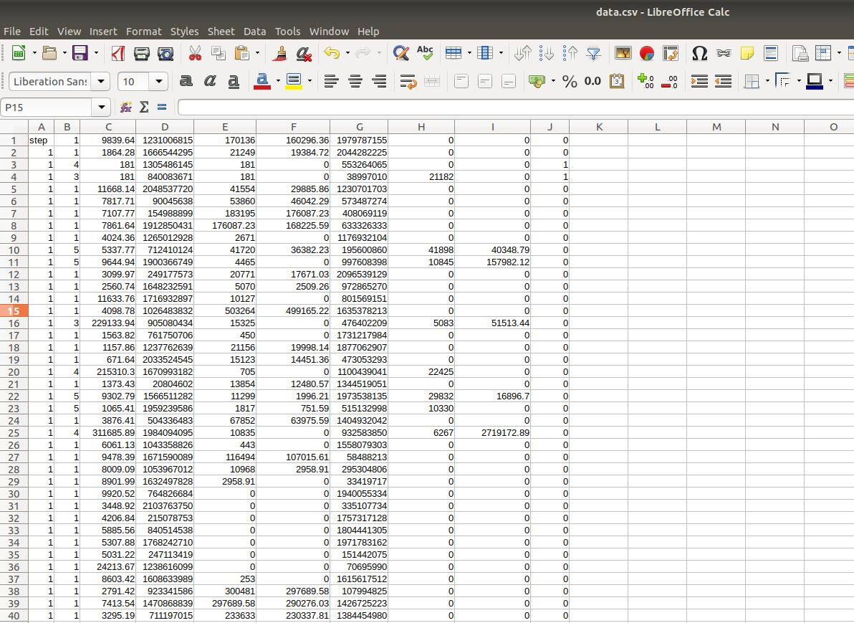

**Data1.csv**

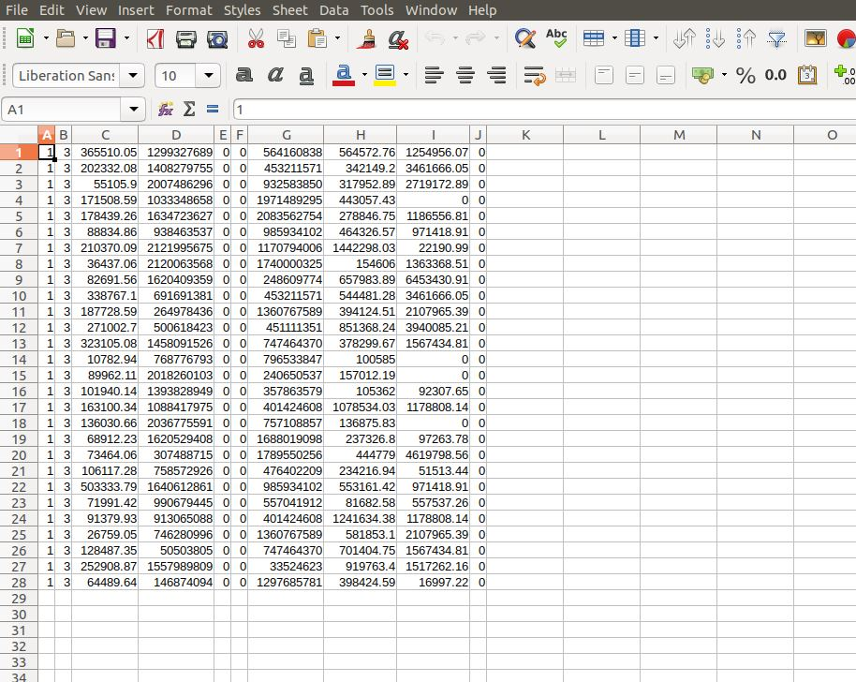

1. **cat** – This command is used to view the whole file content.

We have already discussed this in our previous part, this cat command is used to see the content of a file.

cat <file_path>

As in out terminal, we are currently on Desktop and the files are also on the Desktop so there is no need to change the directory. We can simply see the file content by using the command

cat data.csv

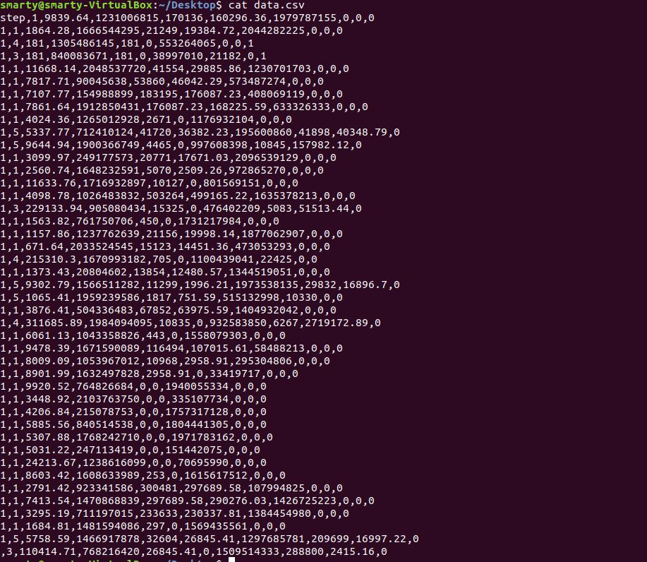

This command will give the whole dataset.

What if you want to view the content of two or more data files with just one command?

In order to do so, you just follow a general syntax i.e.

cat <first_file_path> <second_file_path> <third_file_path> …..

1. less - Unlike “cat” command this command won’t give the whole file content at once, it will break the content into pieces depending upon the file length and display it piece by piece.

Basic Terminologies:

“space_bar” key is used to scroll down the file

“:n” is used to move to the next file

“:p” is used to move to the previous file

“:q” is used to quit the file view.

E.g. If I type “less data.csv” output is like this.

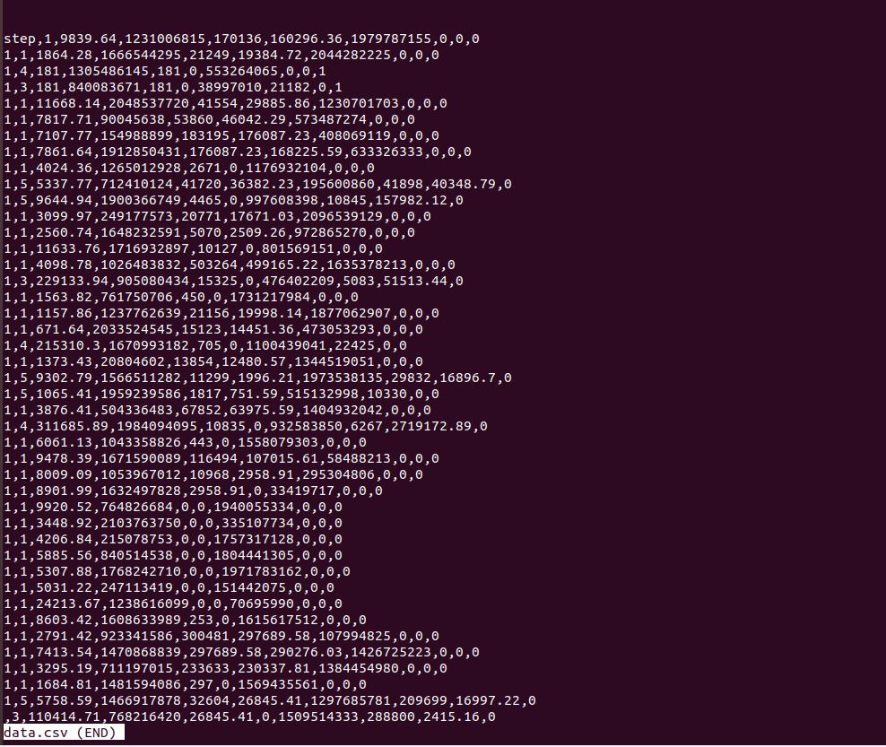

To get out of this window, I just have to type “:q”.

Now I want to open two files at once, we can do it by using

“less data.csv data1.csv”

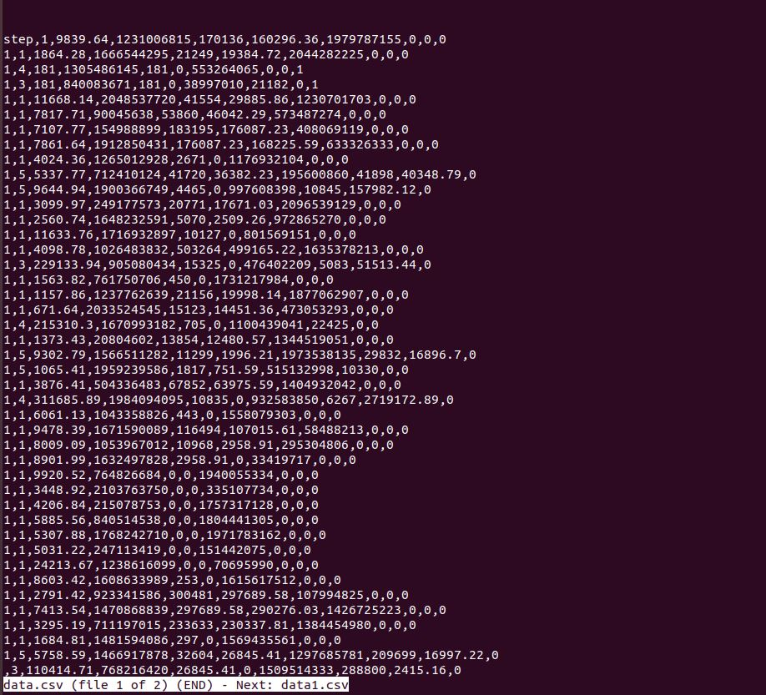

If I want to move to the other file, I can do so by “:n”,

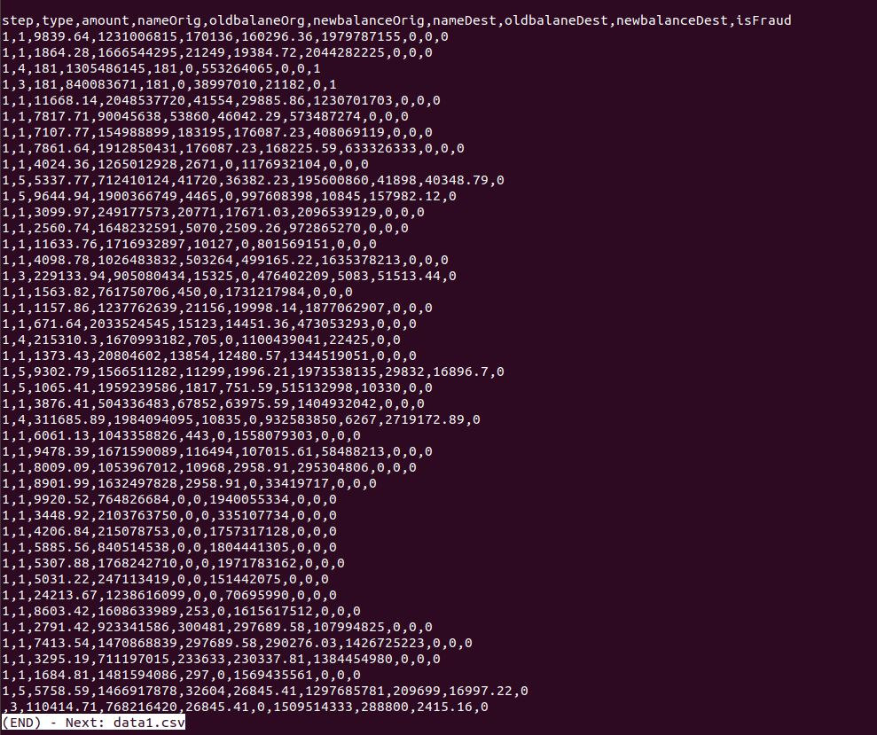

Again to get out of this window you need to type “:q”.

1. **head or tail** – These commands are used to see the start and end of a file.

If I want to filter the first 10 lines of file “data.csv”, I can do so by using the command “head -10 data.csv”

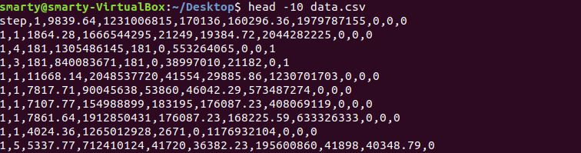

Similarly, if I want to print the last 3 rows I can do it by using the tail command,

“tail -3 data.csv”

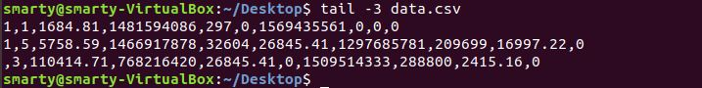

Hence head -n <file_path> and tail -n <file_path> will give the first and last ’n’ rows of the data file.

1. **ls -R** –This command can give the complete description of the files or directories present inside the directory.

Simply type “ls -R” and you will get all the details.

1. **man –** Here man is a short abbreviation of manual, which can give a complete description of any command.

If you stuck on any command or want to explore more about it, then there is a complete manual already made for the shell. You just need to type

“man <command>”

It will give the complete description of that command.

Here I used the command “man head” this will give a complete description of the <head> command.

C:\Users\smarty\Desktop\Capture7.JPG

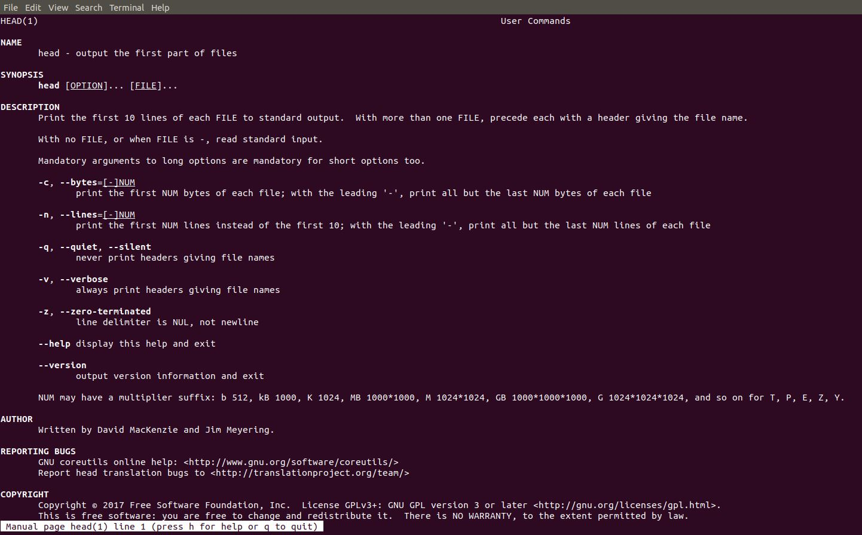

1. **cut -d , -f n** – This command is used to filter the columns from the file.

It happens several times when we want to only one or two specific columns from a dataset. This can be done by using “cut –d , -f n” command.

Here ‘d’ stands for delimiter and as here the file is csv (comma-separated value where the columns are separated by commas) as we set the delimiter as ‘,’.

And –f stands for which feature(column) you want to filter.

Like here I have used the command “cut –d , -f 3 data.csv”.

It will filter the 3rd column from my data set ‘data.csv’ and each column in the dataset is separated by commas ‘,’.

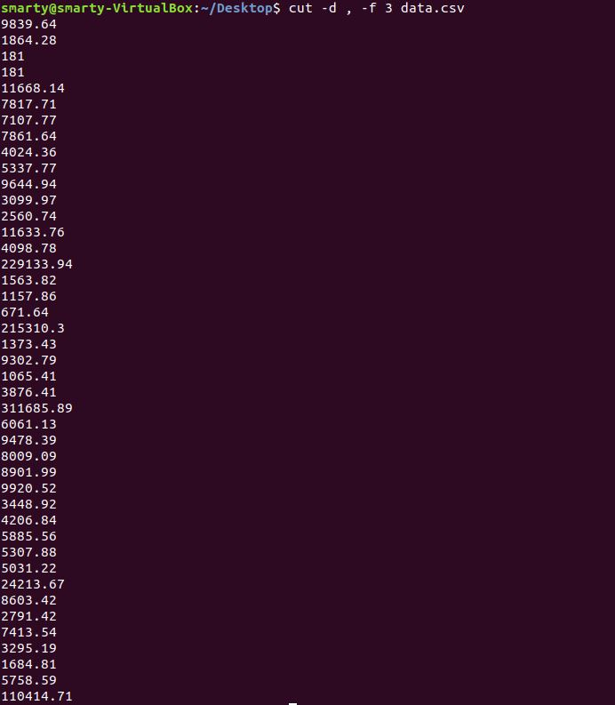

**\*Some Shell command hacks to make your work easy\***

1. If you want to use the exact command or with minor deviation, which you have used earlier, Instead of writing the whole command, again and again, you can simply use arrow keys ‘UP_Arrow’ key to get the previously used commands.

2. If you don’t want to type the whole filename or command, you can simply write the first one or two alphabets of the command and then press “Tab_key” the shell will automatically predict the value.

3. If you stuck at any point or don’t know how the exact syntax or any command, you can simply refer the manual available in shell by simply using the command “man <function_name>”.

4. If your shell stuck at any point then you can use “ctrl + C” keys to get out the current ongoing command.

5. If you want to know all the commands that you have used previously then you can use this command “History”.

6. If you want to cut or paste any command in the shell then you can use the “Ctrl + k” key to cut and “Ctrl +U” to paste.

created by Vidit